**PRACTICAL 3.A**

A pangram is a sentence that contains all the letters of the English alphabet at least once, for example: The Quick brown fox jumps over the lazy dog. Your task here is to write a function to check a sentence to see if it is a pangram or not.

**Code**

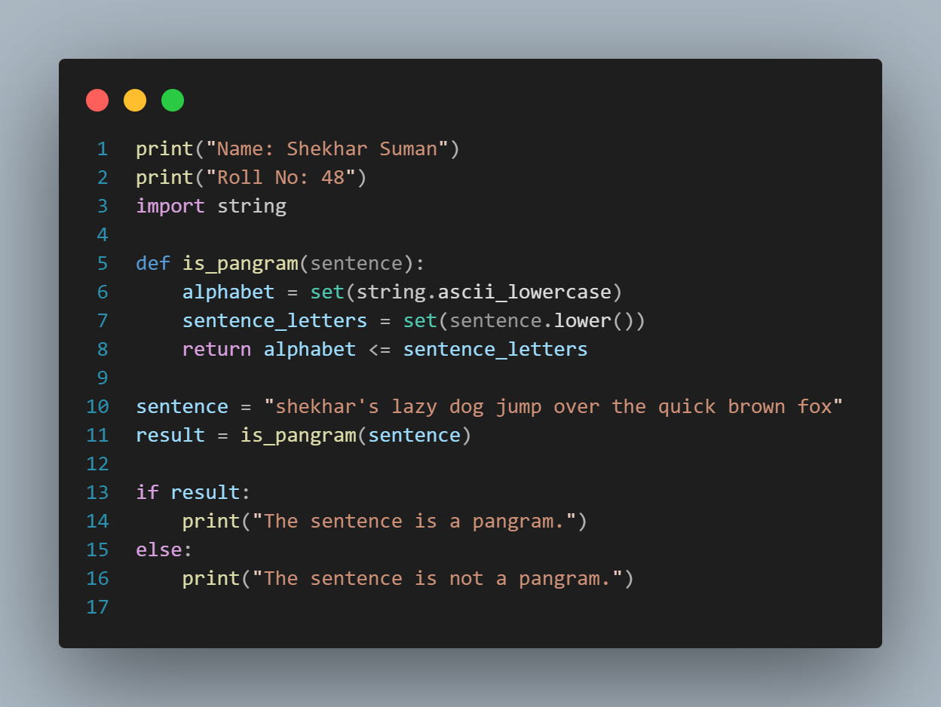

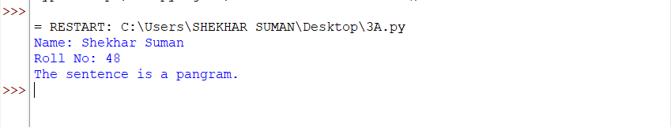**OUTPUT**

**PRACTICAL 3.B**

Take a list, say for example this one: a = [1,1,2,3,5,8,13,21,34,55,89] and write a program that prints out all the elements of the list that are less than 5.

**Code**

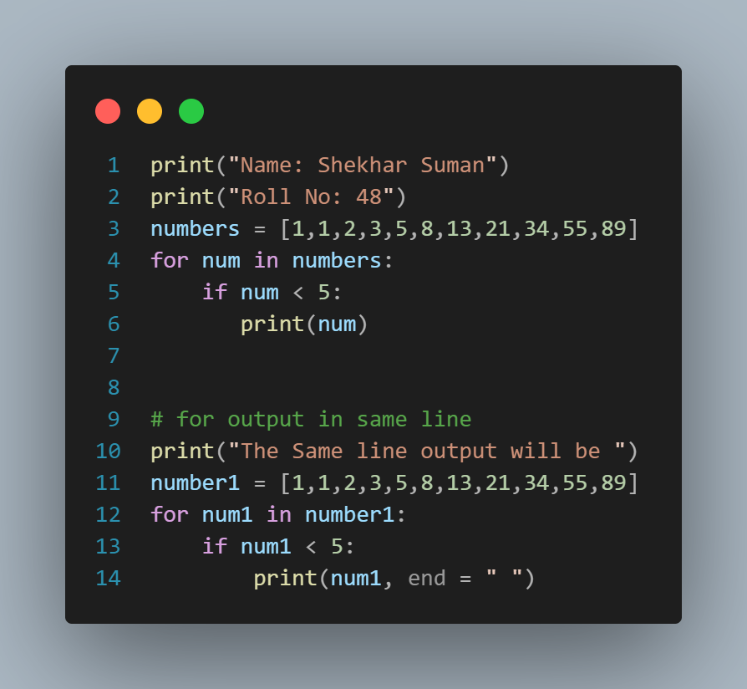

**OUTPUT**

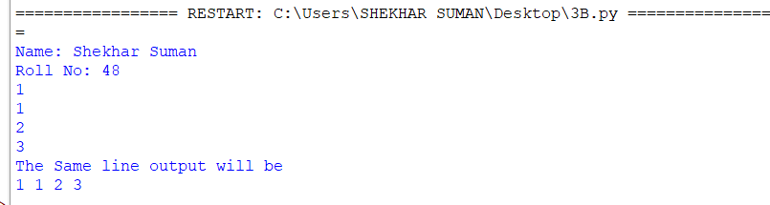

**PRACTICAL 4.A**

Write a program that takes two lists and returns True if they have at least one common member.

**Code**

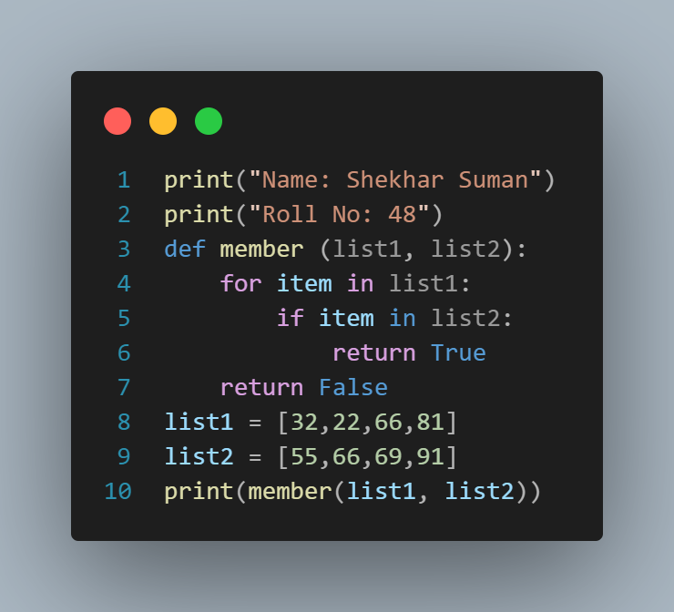

**OUTPUT**

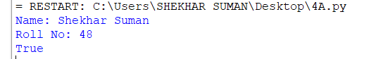

**PRACTICAL 4.B**

Write a python program to print a specified list after removing the 0th, 2nd, 4th, and 5th elements.

**Code**

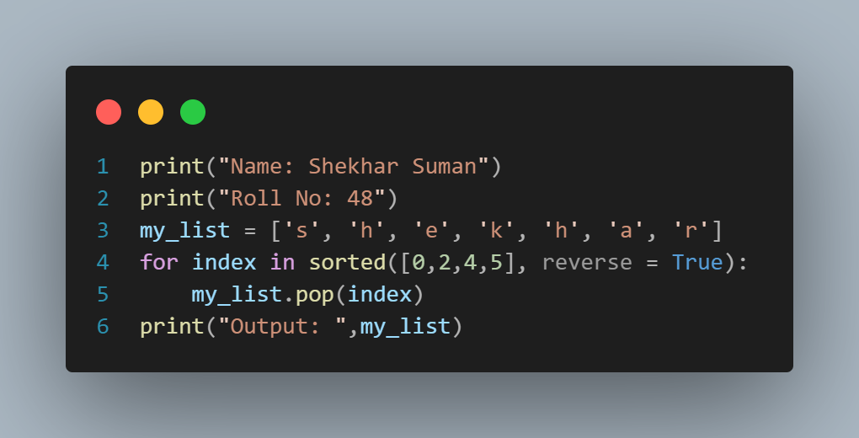

**OUTPUT**

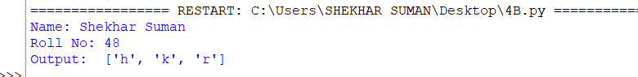

**PRACTICAL 4.C**

Write a python program to clone or copy a list.

**Code**

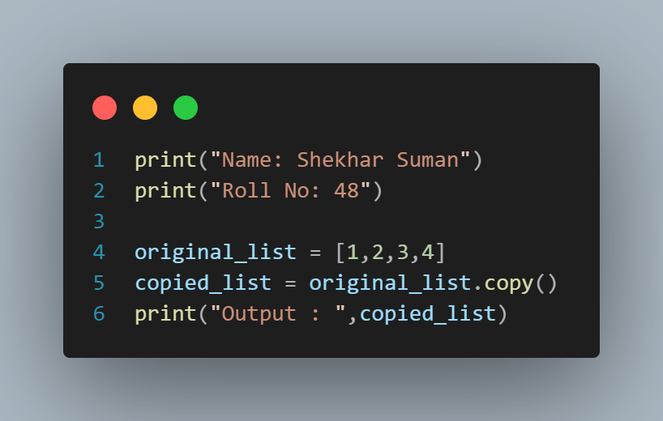

**OUTPUT**

